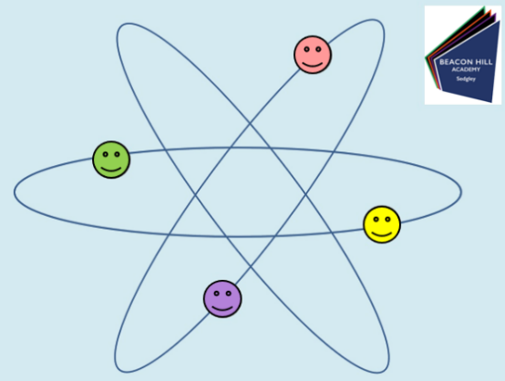
Teach Yourself Science Assignment

Date:________________________
Lesson Number:________________
Title:________________________________
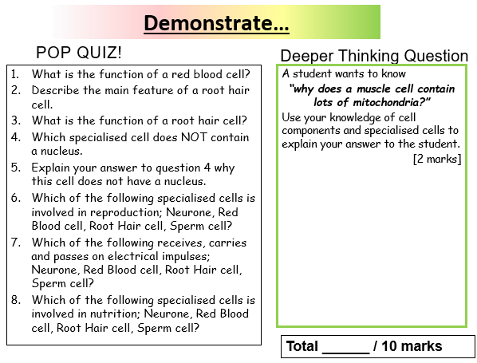
Deeper Thinking Q student response:

Pop Quiz student responses:

Teacher feedback:
WWW

EBI

Remember to save this assignment and send back to your teacher via Teams.

