Plotting your journey

- Using this section of a map (from a part of Wales), choose a route you are going to take between two places/features of the landscape. You ideally want to only go through between five/six of the boxes. Once you have made your decision, draw your route on the map (you do not have to use roads).

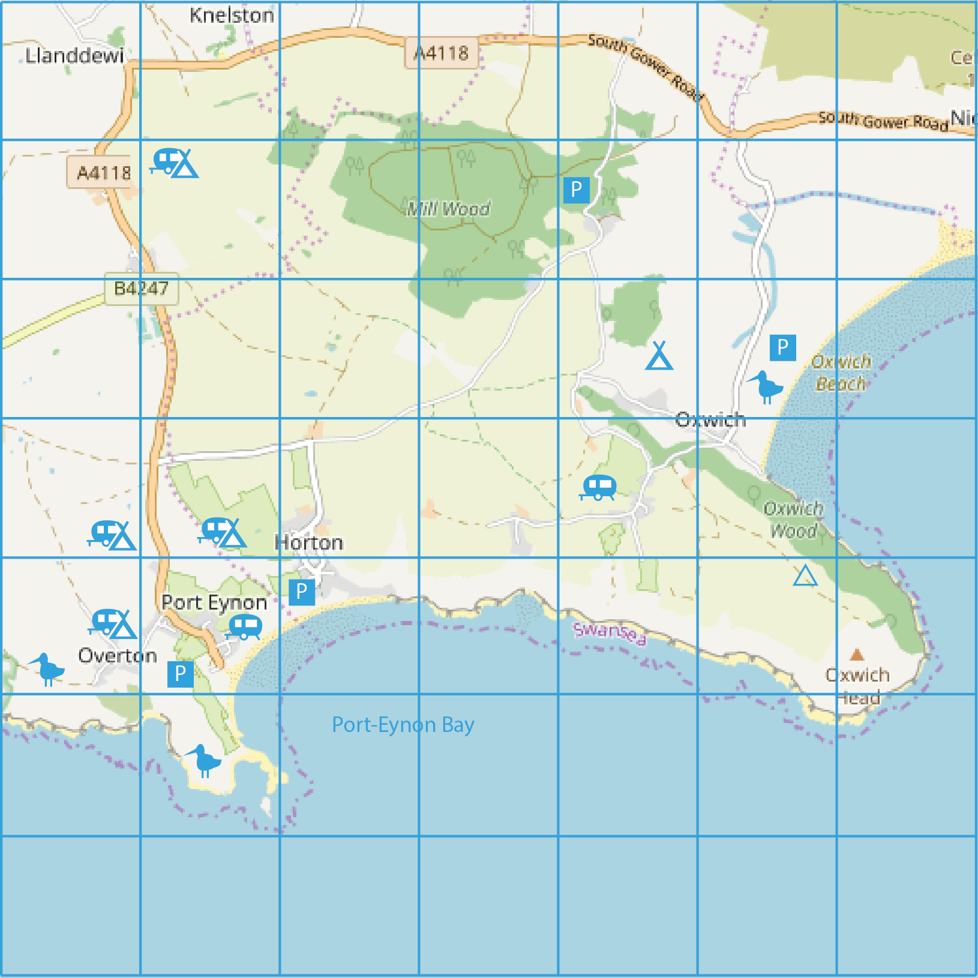

- Using any of the names and features on the map, research some of the places near your chosen route. Find between five and eight images to provide inspiration for your piece of imaginative writing.

- It’s time to think about some of the details of your setting, and stretching your vocabulary. You could:

- print and annotate your images with descriptive words
- create a big mind map of ambitious words
- create a flow diagram of words from the start to the end of your ‘journey’.

- Choose a character, atmosphere and scenario/plot from the grid below. You are going to craft a story shaped around a journey they take between the places you have researched and described.

a young woman | anger | searching for a valuable item (perhaps it has been lost) | a young boy
excitement | a businessman | disappointed | delivering a parcel or letter
walking their dog | taking photographs for a competition | a teenager | an elderly man
anxious | exploring | hopeful | trying to find somewhere quiet to think after arguing with a family member

- Decision time! Think about all your preparation so far and decide how you are going to structure your story. You may not use all the places or images you selected, but should still use some of these to help create a convincing setting.

- In the boxes below, summarise what your character will do/feel/experience as they travel between the places you have chosen.
- The setting does not have to change every time. You might add or remove boxes depending on how long you want your piece to be.

Here’s an example for the first paragraph.

 | Setting | Event/feeling/experience
Paragraph 1 | - Oxwich Head  - early morning  - winter | Clutching letter in hand, feeling nervous about delivering it whilst looking down at the sea.

 | Setting | Event/feeling/experience
Paragraph 1
Paragraph 2
Paragraph 3
Paragraph 4
Paragraph 5
Paragraph 6

- Use your plan to write your piece. Aim to write roughly 400-500 words. You don’t have to cover the entire journey made by your character – focus on developing atmosphere and setting.

