Name:
Section 1 - Where are you up to in English Language?
- Here is a list of the lessons of tasks and lessons on Teams you should have completed since the SJA distance learning programmes started.
- Please review all the tasks and indicate how much you have completed by ticking one of the three columns.
- If you need to complete any of the lessons, click the link on the topic title, which will take you to the YouTube video of the lesson.
- Any extracts you might need for the lessons can be accessed on Teams.
Closure week | Date | Topic | Main tasks | Work Completed  All Some None
1 | 23/03/20 and 30/03/20  Complete the booklets sent home covering Macbeth and AIC revision.
2
3 | 20/04/20 | (Start of work on Teams and pre-recorded lessons)  Lesson 1 – Dracula, Paper 1 Q2 (language)  Lesson 2 – Dracula, Paper 1 Q3 (structure) | Lesson 1 - Timed response to ‘How does the writer use language to describe the weather?’ in the first paragraph to the Dracula extract.  Lesson 2 – Timed response to ‘How has the writer structured the text to interest you as a reader?’
4 | 27/04/20 | Lesson 3 – Dracula, Paper 1 Q4 (evaluation)  Lesson 4 – The Red Room, Paper 1 Q3 (structure) | Lesson 3 – Timed response to ‘A student said: “Stoker has successfully conveyed a sense of fear to the readers. It is as we are there with Jonathan.” To what extent do you agree?’  Lesson 4 – Track the structure of ‘The Lion King’ opening, using your tracking vocabulary, and identifying a range of structural devices
5 | 04/05/20 | Lesson 5 – The Red Room, Paper 1 Q3 (structure)  Lesson 6 – The Red Room, Paper 1 Q3 (structure) | Lesson 5 – Plot on a line graph the events/actions that occurred in the extract from ‘The Red Room’.  Lesson 6 – Timed response to ‘How has the writer structured the text to interest you as a reader?’
6 | 11/05/20 | Lesson 7 – Frankenstein, Paper 1 Q4 (evaluation)  Lesson 8 – Frankenstein, Paper 1 Q4 (evaluation) | Lesson 7 – Evaluate the remaining phrases in the extract.  Lesson 8 – Timed response to the question, ‘A student said: “This part of the story really captures the fears, terror and horror that Victor Frankenstein is going through.” To what extent do you agree?’
7 | 18/05/20 | Lesson 9 – Frankenstein, Paper 1 Q4 (evaluation)  Lesson 10 – The Tell-Tale Heart, Paper 1 Q1 and Q2 | Lesson 9 - Timed response – improve on your answer from lesson 8.  Lesson 10 – Answer the question, ‘How do we know that the narrator is mad in the opening of the extract?’
8 | 01/06/20 | Lesson 11 – The Tell-Tale Heart, Q2 (language)  Lesson 12 – The Tell-Tale Heart, Q2 (language) | Lesson 11 – Focus on the new vocabulary ‘psyche’ and ‘macabre’. Write a paragraph to explain how Poe uses those ideas in his writing.  Lesson 12 - Timed response to the question, ‘How does Poe use language to describe the narrator?’
9 | 08/06/20 | Lesson 13 – The Woman in Black  Lesson 14 – The Woman in Black, Paper 1 Q1 and Q2 | Lesson 13 – Read the extract. Highlight two quotations which specifically address how the fog moves. Highlight two more which suggest to the reader that Arthur feels that the fog has a sinister element.  Lesson 14 – Timed response to the question, ‘How does the writer use language to describe the fog?’
10 | 15/06/20 | Lesson 15 – The Woman in Black, Paper 1 Q4  Lesson 16 – Paper 1 Practice (you will need to access the Insert and Question Paper on Teams) | Lesson 15 – Response to the question, 'This part of the story shows how Arthur was not worried about future events, despite the ominous weather, and was in fact looking forward to it'  How far do you agree?  Lesson 16 – Complete Section A, Reading – questions 1 -4
11 | 22/06/20 | Lesson 17 – Paper 2 Introduction - Ed Gein and Jack the Ripper  Lesson 18 – Paper 2, Q3 – Ed Gein and Jack the Ripper | Lesson 17 – Plan an answer for Q2, comparing the ways in which crimes were committed in the two articles.  Lesson 18 – Plan an answer to Q3. Timed response to the question, ‘How does the writer use language to convey his opinions of the killings?’ (in lines 1-10 of Source B, Jack the Ripper)
12 | 29/06/20 | Lesson 19 – Serial Killers, Paper 2 Q4  Lesson 20 – Street Beggars, Paper 2 Q2 | Lesson 19 – Timed response to the question, ‘Compare how the writers convey their attitudes to the murderers that they describe.’  Lesson 20 – Write a summary of the differences between the street beggars of Beirut and the street beggars of St James’s park.
13 | 06/07/20 | Lesson 21 – Paper 2 Q2  Lesson 22 – Serial Killers, Paper 2 Q3 (Source B) | Lesson 21 – Use details from both sources A an B. Write a summary of the differences between the Ragged Schools and the schools in Africa.  Lesson 22 – Use the information to answer the questions: ‘Find a phrase that shows Resendix is not remorseful.’ ‘What is the significance of the phrase ‘half-man half-angel?’ and ‘What impression do we get of the serial killer?’

Section 2 - Where does that fit into my GCSE English Language exams?
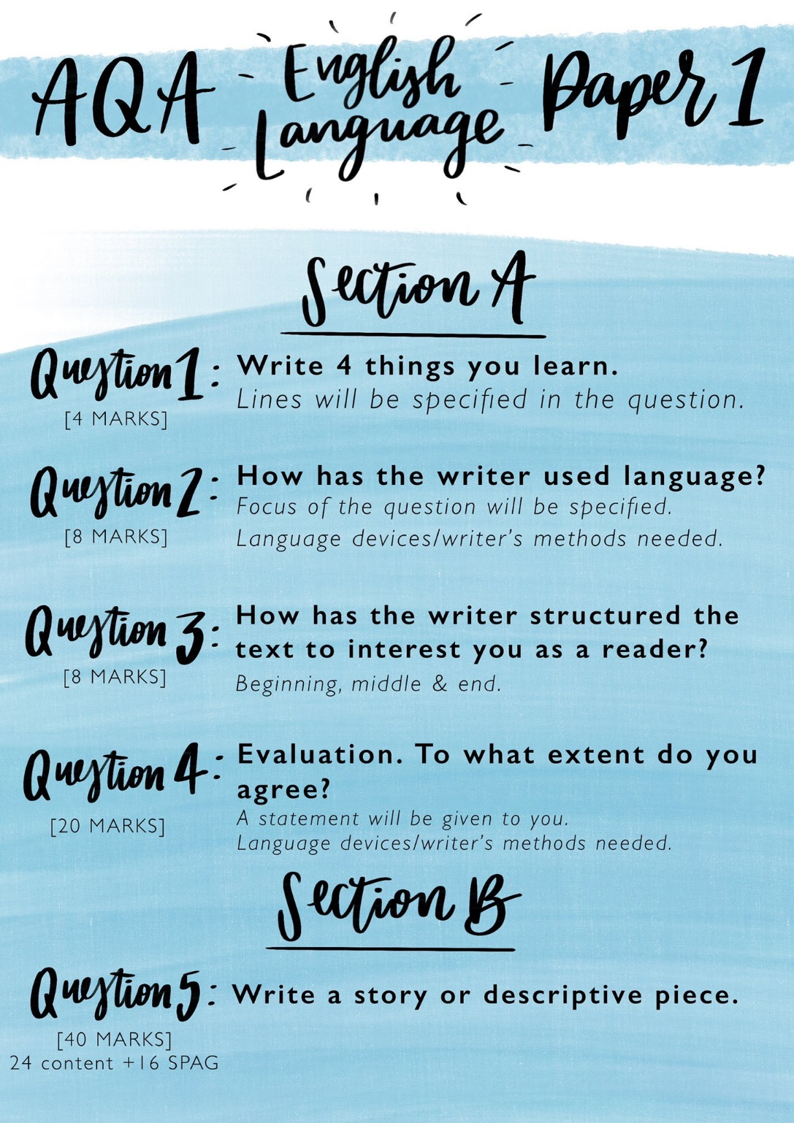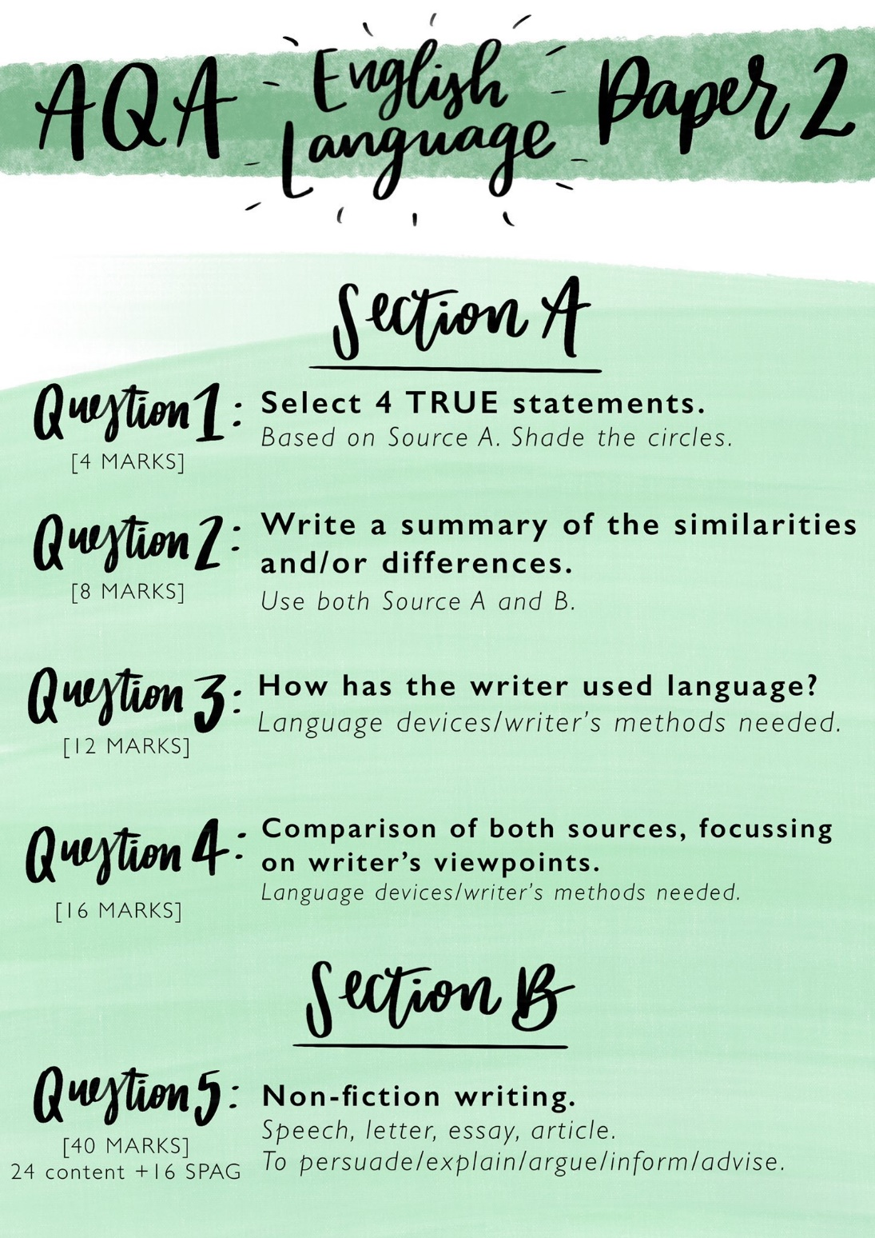

Section 3 - What should I do now to prepare for my GCSE course?
Tasks to complete now
- Make revision notes on the English Language exams.
- Complete outstanding Teams lessons and tasks.
- Complete Century Tech Diagnostics (if you need any help with your log in then please email ‘onlinelearning@stjamesacademy.org.uk)
- Jekyll and Hyde video lessons and text – all on the Year 10 section of Distance Learning tab on the school website. https://www.stjamesacademy.org.uk/page/?title=English&pid=169
Some Resources to support you
- https://members.gcsepod.com/teachers/teach - GCSEPod videos for English Language
- https://www.bbc.co.uk/bitesize/examspecs/zcbchv4 - AQA BBC bitesize GCSE English Language revision
- https://www.youtube.com/playlist?list=PLTO8p8hoj-A6xWBdXoT4rz6V4rxMIChaN – Free GCSE English Live lessons – analysis of language
- https://www.youtube.com/channel/UCM2vdqz-7e4HAuzhpFuRY8w - Mr Bruff YouTube Videos for AQA English Language

10 Steps to Success – Complete these steps to reach your goal

Activity | R | A | G
- Log on to www.gcsepod.com and select a topic. Start learning vocab and earning points.

- Log in to www.century.tech and complete diagnostics from the topics you have learnt. Do you know your Log In details?

- Read news articles on www.theguardian.com. Write a summary of the article.

- Visit www.bbc.co.uk/bitesize and watch videos, complete activities and tests on all the GCSE topics.

- Make revision cards with questions and practice recalling your answers. Topics could include language and structural devices or subject terminology.

- Create your own Top 10’s of key phrases and words (opinions / connectives / sentence openers / evaluative phrases / analytical vocabulary / comparison points / academic gesture).

- Complete a mind map for each subtopic in the AQA English Language Revision Guide.

- Complete practice exam questions from the AQA Revision Guide workbook.

- Complete the Reading and Writing practice questions in your workbooks provided in class.

- READ! Novels, plays, articles, newspapers, blogs, reviews. At least 20 minutes per day!

